**Name:____________________________________ Class:_____ ( )**

**Tuesday English News Report: Broadcast Date: 5th Nov, 2019**

***NASA Astronauts Complete the First All-Female Spacewalk***

NASA reached a **mileston**e on Friday when two Americans, **tasked** **with** replacing a power controller, ventured out of the International Space Station: the astronauts, Christina Koch and Jessica Meir, became the first to take part in an all-female spacewalk.

The walk, which lasted seven hours and 17 minutes and included a **brief** call with President Trump, was not purposefully planned by the agency.

But news of the milestone attracted far greater interest than spacewalks normally do, and on Friday, American officials celebrated it as a historic achievement. They pointed to the agency’s **ambitious** goals to put the first woman and the next man on the moon, and then to forge a path to Mars.

Live video of the spacewalk showed two figures in **bulky** white gear — first Ms. Koch, then Dr. Meir — working outside of the space station, which glowed against the blackness of space. The women could be heard talking to controllers, and helmet cameras showed the view as they clambered along the outside of the space station.

Such a walk was supposed to take place in March, but it was **postponed** because NASA [did not have two appropriately sized spacesuits](https://www.nytimes.com/2019/03/25/science/female-spacewalk-canceled.html?module=inline) available. That **sparked** an **outcry** — and [a “Saturday Night Live” spoof](https://www.youtube.com/watch?v=SUJUlcXXt2k) — about the legacy of sexism in the space program. For some observers, the episode underscored the challenges faced by women in fields where equipment has historically been designed with men in mind.

Women were not **admitted** into the astronaut program [until 1978](https://www.nasa.gov/multimedia/imagegallery/image_feature_1624.html), and an American woman did not fly into space until [Sally Ride](https://www.nytimes.com/2012/07/24/science/space/sally-ride-trailblazing-astronaut-dies-at-61.html?module=inline) did so in 1983. Two Soviet women **preceded** her. The first spacewalk took place in 1965, and in 1984, [Kathryn D. Sullivan](https://airandspace.si.edu/stories/editorial/america%E2%80%99s-first-spacewalking-woman-kathryn-d-sullivan) became the first American woman to perform one.

“You’re doing an incredible job,” Mr. Trump told the astronauts on Friday during a call to the space station. He called the moment “the first time for a woman outside of the space station,” an inaccuracy that Dr. Meir gently corrected. She is the 15th woman to do a spacewalk, but until Friday, all of those astronauts had been paired with male colleagues.

*Source: The New York Times*

**Questions to think about:**

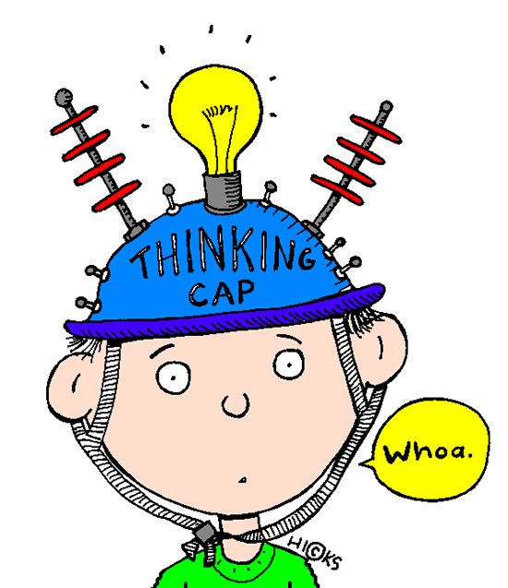

Thinking cap

* Do you think this is a newsworthy item? Why, or why not?
* In this field of work, do women face more challenges than men? What

are these challenges?

* What is the appeal or attraction of space exploration?
* Space exploration is expensive. Do you think it is worth spending

money on?

* What are some potential problems or issues with space exploration?
* Do you think space exploration by private companies should be encouraged? Why, or why not?

1. **I: Vocabulary and understanding meaning**

*Match the meaning and/or synonym to the words which have been highlighted in bold in the article.*

|  |  |  |
| --- | --- | --- |
| **Column A: Word from text** | **Letter** | **Column B: Meaning or synonym** |
| 1. milestone (n) |  | A: short |
| 1. task with (phrasal verb) |  | B: put off, delay until a future date |
| 1. brief (adj) |  | C: to be given the job of |
| 1. ambitious (adj) |  | D: heavy |
| 1. bulky (adj) |  | E: ignite, set something in motion |
| 1. postpone (v) |  | F: a strong expression of public disapproval or anger |
| 1. spark (v) |  | G: a significant stage or event in the development of something |
| 1. outcry (n) |  | H: allow something or someone into a place or field/area of work etc |
| 1. admit (v) |  | I: to come before something in time |
| 1. precede (v) |  | J: to have a strong desire to succeed |

**II: Usage of vocabulary:** *Fill in the missing words of the sentences below using the vocabulary (1-10) from column A. The words in brackets or italics may help you. Make sure your answers are grammatically correct.*

1. The first steps Neil Armstrong took on the moon in 1969 was a (a) ________________ in the history of space exploration. It was *an event that attracted attention all over the world*, *the first of its kind.* Neil Armstrong (b) _________________________, in other words, *given the job of* taking the first steps on the moon. *Before this significant event*, in other words, (c) ________________ the walking on the moon, there had been other attempts. The first human-made object to touch the Moon was the [Soviet Union](https://en.wikipedia.org/wiki/Soviet_Union)'s [Luna 2](https://en.wikipedia.org/wiki/Luna_2), on 13 September 1959. The next (d) _________________ or *challenging* project in space exploration is to seek a gateway to Mars.

2. The football match had to be ________________ to another date because of the typhoon.

3. The ‘Me Too’ Movement (a) _____________________ (was started) by an (b) _________________ (public outrage/anger) against men sexually harassing women when American actress Alyssa Milano shared her story of sexual assault by Harvey Weinstein, the former American film producer.

3. What a _______________ package! I wonder what is in it. *I can hardly lift it*.

4. *As I was running out of time*, I asked the caller to keep the phone call ____________.

5. Each ticket only ______________ one adult, in other words, *only one adult can enter on each ticket*.

