**Tuesday English News Report**

*Hong Kong government must change its policy to* ***embrace*** *cycling culture*

Broadcast Date: 6th October

Amid a slowdown in visitor numbers, the authorities are **banking on** cycling fever to **boost** the **ailing** tourism industry.

Thousands of local and foreign bikers will pedal around some of Hong Kong's landmarks in the city's first cyclothon next month.

The initiative not only has the **potential** of becoming another signature event like the annual marathon run, it may also help instill a wider cycling culture and **nurture** a more cyclist-friendly environment and policy.

Whether the new event can attract overseas visitors remains to be seen. But the Tourism Board is right in saying that cycling fever has swept the city.

Increasingly, weekend and night-time cycling have become a popular leisure activity among youngsters and families.

The positive response to the city's first cyclothon - more than 3,000 have registered to take part - underlines the growing importance of cycling among the population.

Unfortunately, the **trend** is not matched by institutional changes. Our roads are designed for vehicular traffic. People riding bikes are never respected as equals by those sitting behind steering wheels.

This is **exacerbated** by a government that does not regard cycling as a form of transport.

But in reality, cycling is not uncommon in the New Territories, with people using it as a way of commuting as well as recreation.

This has resulted in frequent accidents, which number around 2,500 to 2,700 each year.

The lack of a sound policy and infrastructure sits oddly with cycling's growing popularity.

Our government is aware of the trend, but is only willing to step up road safety campaigns rather than changing its outdated transport policy.

The merits of cycling have long been recognised by some cities overseas. Not only is it an eco-friendly **mode** of transport, it also adds to the city's character, as in the case of Amsterdam.

In fact, cycling has such a growing appeal that many cities have introduced bike-sharing schemes for locals and tourists alike.

With the right policy and approach, the government can improve Hong Kong's transport **infrastructure** and help people stay healthy, too.

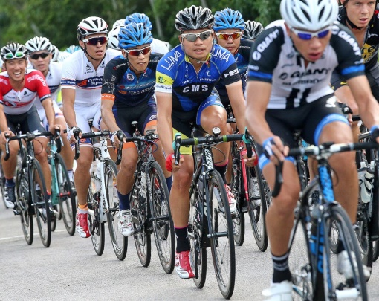

1. What do you think?
2. Vocabulary

*Fill in the blanks in the sentences below using words from the box.*

|  |  |  |  |
| --- | --- | --- | --- |
| embrace | banking on | boost | ailing |
| potential | nurture | trend(s) | exacerbated |
| mode(s) | infrastructure |  |  |

1. Trains, buses, taxis and cars are all different ___________________ of transport.
2. This student has a lot of _____________________. If he works hard, he can get a scholarship to study at Cambridge University.
3. This means getting worse or getting sicker. The economy in Australia is _____________ due to the fall in demand for its natural resources.
4. Eating fresh fruit and vegetables can _______________________ your energy levels.
5. This has the same meaning as “relying on” or “depending on”. John is _______________ his friend’s help to pass the exam.
6. ________________ means to help something grow and develop.
7. If you ____________________ someone, you put your arms around them. It also means to accept something new.
8. His feelings of sadness and depression were ___________________ (made worse) by the uncaring attitude of those around him.
9. Many _____________________ in fashion come from Korea nowadays.
10. The communication and transport systems form part of the ______________________ in a city.

**Breaking news!**

**The English Room is Open EVERY DAY for Lunch!**

**(Open from12:30-1:30).**

**☺ FREE Coffee /Mil / soft drinks with Mr. Lane!**

**Where: The English Corner (Room B001B by the basketball court)**

**Play games, watch films and speak ENGLISH in a friendly ENVIRONMENT. Challenge Mr. Lane to a game of chess, too! So far he is unbeaten!!!**

1. Vocabulary Answers

*Fill in the blanks in the sentences below using words from the box.*

1. Trains, buses, taxis and cars are all different **modes** of transport.
2. This student has a lot of **potential**. If he works hard, he can get a scholarship to study at Cambridge University.
3. This means getting worse or getting sicker. The economy in Australia is **ailing** due to the fall in demand for its natural resources.
4. Eating fresh fruit and vegetables can **boost** your energy levels.
5. This has the same meaning as “relying on” or “depending on”. John is **banking on** his friend’s help to pass the exam.
6. **Nurture** means to help something grow and develop.
7. If you **embrace** someone, you put your arms around them. It also means to accept something new.
8. His feelings of sadness and depression were **exacerbated** (made worse) by the uncaring attitude of those around him.
9. Many **trends** in fashion come from Korea nowadays.
10. The communication and transport systems form part of the **infrastructure** in a city.

.