**Name:____________________________________ Class:________ ( )**

**Tuesday English News Report**

*Hong Kong concern group* ***petitions for*** *Mid-Levels* ***preservation***

Broadcast Date: 3rd November

A group of activists and district council election candidates on Thursday went to a Mid-Levels redevelopment site to petition for the preservation of an old shop sign – only to see workers cover it up with a large sheet of black canvas before fencing off the building, helped by police.

The call for a **halt** to **demolition** of buildings in the area was issued by the Central and Western Concern Group after it consulted **heritage** restoration specialist Wong Hung-keung and estimated the Ying Kee Hard Coal shop sign at 21 Peel Street dated back at least 70 years.

They also said remains of tenement houses on Cochrane Street, also part of the Urban Renewal Authority project site, could have been built between the 1830s and 1911 and should be **conserved**.

The Graham Street project, a plan to redevelop Hong Kong’s first wet market into a commercial and residential zone, was first announced by the now-**defunct** Land Development Corporation 17 years ago and was revived by its successor, the URA, nine years ago.

Around 10 people, including district councillors and community organisers of the Democratic Party, visited the site on Thursday afternoon to petition for an immediate investigation into the immediate area's heritage values.

“We were to hand a petition letter to the URA. But then about 10 construction workers and police officers came with fences and tools. The workers soon **fenced off** the building and covered the shop sign,” said party member Ng Siu-hong, who is running in the Mid-Levels East constituency against **incumbent** district councillor Jackie Cheung Yick-hung, an independent.

The concern group has now written to the URA and development secretary Paul Chan Mo-po, urging them to “make timely intervention to save this heritage item which reflects the history of our old street market in Central”.

A spokeswoman for the URA said: “Since we heard the opinions recently, we have already contacted relevant government departments and will **collaborate** as much as we can if there is any work needed.”

However, she stopped short of saying whether the workers’ latest action was related to demolition of the building. On Tuesday, the URA said it had not been required to submit a heritage impact assessment report and the plan was approved by the Town Planning Board in 2007.

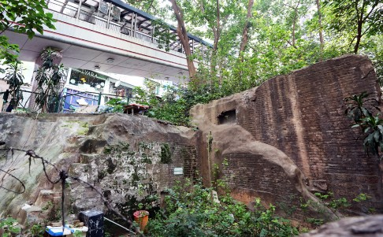 New discoveries of remains of Graham Street market near the inte

1. What do you think?
2. Vocabulary

*Fill in the blanks in the sentences below using words from the box.*

|  |  |  |  |
| --- | --- | --- | --- |
| petition(s) for | demolition | defunct | collaborate |
| preservation | heritage | fence(d) off |  |
| halt | conserve(d) | incumbent |  |

1. It is time to put a ___________________ to (stop) deforestation in the Amazon rainforest.
2. I think the government should concern itself with the __________________ of important historical buildings in Hong Kong. We have lost so much already.
3. The meaning of this word is that the person is currently holding that position. The _________________ President of the USA is Barack Obama.
4. To _____________________ means to work with someone together with someone on a joint project.
5. No longer living, operative or valid. Students of the ___________________ Clapham Art School had a reunion 20 years after it closed down.
6. The ____________________ of the building was very quick. It collapsed after the explosive charges were set off.
7. Farmers often __________________________ parts of their land that they don’t want people or animals to enter.
8. Something that is handed down from our ancestors such as culture or tradition. We always celebrate Christmas on the evening of the 24th December. It comes from my German ___________________.
9. We need to ___________________ things from the past that define our culture.
10. We _________________ something by getting many people to sign a document asking for a change of policy etc.

**Breaking news!**

**The English Room is Open EVERY DAY for Lunch!**

**(Open from12:30-1:30).**

**☺ FREE Coffee /Milo / soft drinks with Mr. Lane!**

**Where: The English Corner (Room B001B by the basketball court)**

**Play games, watch films and speak ENGLISH in a friendly ENVIRONMENT. Challenge Mr. Lane to a game of chess, too! So far he is unbeaten!!!**