**Tuesday English News Report**

*Hong Kong teenager in need of new* ***lungs*** *(Organ Donation)*

Broadcast Date: 13th October

A teenager in urgent need of a double lung **transplant** was counting down her final hours last night amid signs of multiple organ failure after a donor could not be found to keep her alive.

The condition of Jamella Lo, 19, continued to **deteriorate** as her family and friends **flocked to** Queen Mary Hospital in Pok Fu Lam to be by her side at the end of the long weekend for the Mid-Autumn Festival.

Lo was in a critical condition at the hospital's intensive care unit after developing **symptoms** of primary **pulmonary** hypertension - a rare condition that leads to narrowing of the blood vessels in the lungs, which causes high blood pressure.

On Sunday, Lo's doctor, Timmy Au Wing-kuk, said she would only have about 48 hours to live if she did not receive a new pair of lungs. No **donor** emerged over the long weekend, and yesterday Au said Lo's condition continued to worsen.

He said her blood pressure had turned unstable and she had displayed symptoms of an infection and multiple organ failure. A pump keeping her alive by taking on the functions of her heart and lungs had to be changed for another one as it was blocked by blood clots, he said.

Lo's father, James Lo Yun-fai, said he only had one wish for the Mid-Autumn Festival, during which Chinese families traditionally get together.

"I hope she will recover," he said. "I hope somebody of goodwill can **donate** their lungs."

He said the family had still not lost hope and were waiting for a miracle to happen.

Secretary for Food and Health Dr Ko Wing-man **urged** the public to consider donating the organs of **deceased** relatives.

The teenager's lungs failed suddenly early this month when she was in Zhejiang province on a school trip. Lo was sent to Sir Run Run Shaw Hospital in Hangzhou for treatment and to Hong Kong's Tseung Kwan O Hospital a week later.

She is one of an average of three or four patients a year in Hong Kong afflicted by primary pulmonary hypertension.

[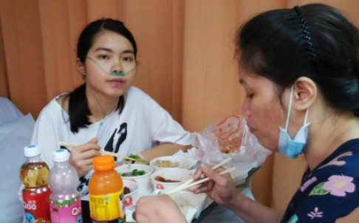](http://cdn3.scmp.com/sites/default/files/styles/980w/public/2015/09/28/7e6cb45d4c23f74eb591f249c3dc7cf1.jpg?itok=8sBiyhn9)

Patient Jamella Lo (left) with her mother.

1. What do you think?
2. Vocabulary

*Fill in the blanks in the sentences below using words from the box.*

|  |  |  |  |
| --- | --- | --- | --- |
| lungs | flock(ed) to | donor | deceased |
| transplant | symptoms | donate(d) |  |
| deteriorate(d) | pulmonary | urge(d) |  |

1. _______________________ means dead.
2. The ____________________ of flu are a fever, coughing and aching muscles.
3. A ______________________ is someone who gives something.
4. To come to see someone or something in great numbers. Thousands of people ______________________ to see the Pope when he visited the UK.
5. The running coach ___________________ his students to run faster and not give up.
6. Anything connected with the lungs is called ______________________________.
7. The organs we use for breathing are called the __________________________.
8. After his heart attack, his health _______________________ rapidly and he died soon after.
9. Bill Gates has ____________________ large sums of money to charity.
10. Dr. Christiaan Barnard performed the first heart ____________________ on December 3rd, 1967 in South Africa.

**Breaking news!**

**The English Room is Open EVERY DAY for Lunch!**

**(Open from12:30-1:30).**

**☺ FREE Coffee /Milo / soft drinks with Mr. Lane!**

**Where: The English Corner (Room B001B by the basketball court)**

**Play games, watch films and speak ENGLISH in a friendly ENVIRONMENT. Challenge Mr. Lane to a game of chess, too! So far he is unbeaten!!!**