**Name:____________________________________ Class:________ ( )**

**Tuesday English News Report**

*Don’t throw out your New Year tangerine trees, says Hong Kong green group*

Broadcast Date: 16th February

A conservation group is calling on the public to **ponder** the environmental impact of some 40,000 tangerine trees they **purchase** and then throw out every Lunar New Year, most of them **destined for** the city’s overflowing landfills.

Once again about 1,400 tonnes of “lucky” tangerine trees are expected to be **disposed of** at the end of this holiday season, roughly the same as last year, according to the Tai Po-based Environmental Association.

Association chief executive Dr Yau Wing-kwong said the lack of any **mandatory** waste charging gave Hongkongers no **incentive** to keep the trees at home. A lack of awareness of how these plants could be recycled and regrown as easily as any potted plant did not help either.

“We should respect all life forms. Throwing them out after just a couple of weeks is wasteful and adds more pressure to our landfills,” said Yau, adding that the weight of disposed trees every year was equivalent to about 60 double-decker buses.

He hopes a six-year-old tangerine tree recultivating programme at the Fung Yuen Butterfly Reserve, which the association runs, can set an example for a city which recycles just a little over 2.5 per cent of all tangerine trees on the market.

Since 2010, the group has collected about 4,000 trees, mainly from shopping malls, and replanted them on the hills of the Tai Po reserve or given them to organisations willing to take them such as the Hong Chi Association.

The plants’ leaves provide a **valuable** source of food and nesting grounds for at least seven species of butterfly including the Asian swallowtail, the Red Helen and the Common Mormon .

Those at home can do the same, Yau stressed. Tangerine trees are evergreen and can bear fruit throughout the year in several growth cycles if **pruned** and cared for properly. “It can be done easily and does not require any professional gardening skill.”

To regrow the plants organically, all that is needed is to **trim** their leaves and roots by about a third and give them a change of soil. Organic **fertiliser** will need to be applied regularly and pruning would be needed four times a year.

The Lunar New Year is one of the least environmentally friendly holiday seasons, with about 320 million red envelopes **doled out** at the expense of 16,300 trees. Residents also get rid of large quantities of packaging and old clothes and furniture.

[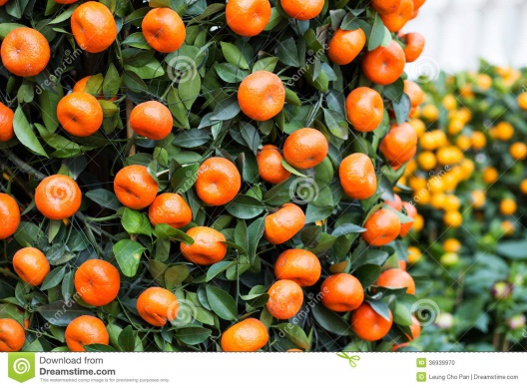](http://www.google.com.hk/url?sa=i&rct=j&q=&esrc=s&source=images&cd=&cad=rja&uact=8&ved=0ahUKEwj3pqGRw9XKAhXm5qYKHeOfCiMQjRwIBw&url=http://www.dreamstime.com/photos-images/chinese-new-year-orange-tree.html&psig=AFQjCNG4zft2K8RQFGzZseTCEB3ySofl6w&ust=1454380221381145)

1. What do you think?
2. Vocabulary

*Fill in the blanks in the sentences below using words from the box.*

|  |  |  |  |
| --- | --- | --- | --- |
| ponder | purchase | destined for | disposed of |
| mandatory | incentive | valuable | pruned |
| trim | fertiliser | doled out |  |

1. If the man didn’t ______________ his beard, it would grow out of control.
2. He told his daughter he would give her $1000 if she passed all her exams. This was a big __________________ for her so she began to study harder.
3. School uniforms are _______________________ in most Hong Kong schools. You must wear them.
4. Modern ______________________ is made from chemicals. Farmers use it to help their plants grow.
5. You can ___________________ cheaper fruit and vegetables if you go to a wet market instead of a supermarket.
6. Roses should be _____________________ (cut back) any time between January and April.
7. She began to _______________________ why he had said what he had said. It really didn’t make sense.
8. For someone who is dying, time is more ____________________ than all the gold in the world.
9. The student got excellent results in his exams. He is __________________________ great things.
10. He __________________________ his empty paper cup in the litter bin.
11. She set up a stall in the street and _______________________ hot soup to poor, homeless people in need.

**The English Room is Open EVERY DAY for Lunch!**

**(Open from12:30-1:30).**

**☺ FREE Coffee /Milo / soft drinks with Mr. Lane!**

**Where: The English Corner (Room B001B by the basketball court)**

**Play games and speak ENGLISH in a friendly ENVIRONMENT. Challenge Mr. Lane to a game of chess, too!**